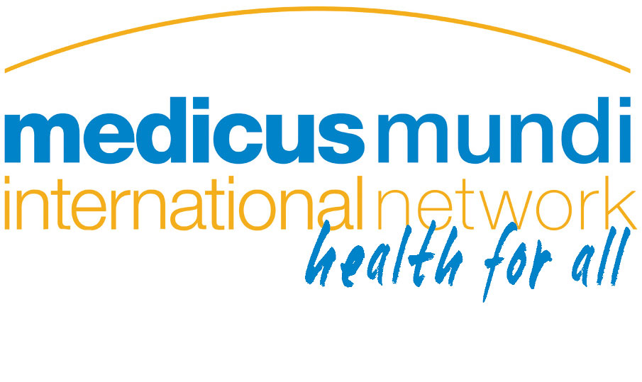
Statement to the 68th World Health Assembly
on agenda item 15.1 (Anti-microbial resistance)
Thank you, Chair, for the opportunity of addressing the distinguished delegates to the WHA on behalf of MMI and PHM.
We commend the Secretariat and the member states for preparing the GAP and for highlighting the misuse and overuse of antimicrobial medicines in humans and animals and the need for strong and effective regulatory regimes.
Intensive industrial food production is a major driver of antibiotic resistance. The use of antibiotics as growth enhancers and overcrowding, unhygienic conditions, inappropriate diets, and early weaning drive routine antibiotic administration. We urge MS to commit to phasing out the non-therapeutic use of antimicrobial medicines in animal health.
Environment pollution via livestock waste, sewage, industrial meat processing waste, and hospital disposal all contribute to the spread of resistance and need to be monitored and controlled.
Health systems strengthening will be needed to ensure appropriate use of anti-microbials including regulation of the marketing and use of antibiotics. Mandatory provisions will be needed to ensure adequate surveillance of antibiotic use in human and veterinary medicine and livestock production.
The GAP is weak in relation to accountability. We urge WHO to develop robust standards against which national action plans can be measured and to put in place rigorous accountability mechanisms to ensure they are implemented. However, many developing countries will require financial and technical assistance in order to implement their national plans. Surveillance mechanisms, lab capacities, health system strengthening, human resources all need huge investments.
The fact that no new class of antibiotics has been developed in the last 30yrs, underscores the urgency to accelerate R&D for new antibiotics. Profit driven priority setting has failed to drive innovation in this important area. The mobilising of funds for R&D needs to be delinked from monopoly pricing and anticipated profits.
The statement will be delivered by: David Legge
Contact for enquiries: dlegge@phmovement.org +61 408 991 417

