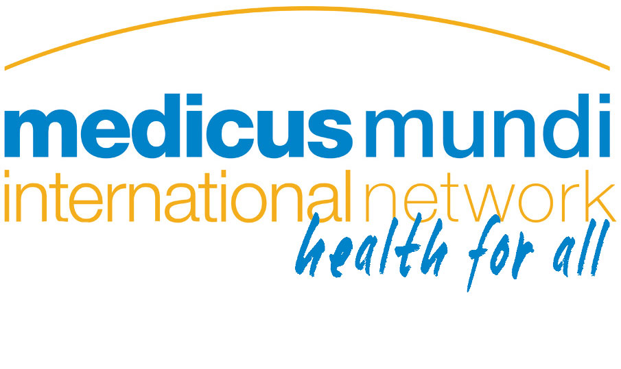
Statement to the 68th World Health Assembly
on agenda item 17.4 Follow up of the Consultative Expert Working Group on Research and Development: Financing and Coordination
Thank you Chair. I take the floor on behalf of MMI and PHM.
The CEWG was given the mandate to address structural issues related to R&D, including through the de-linkage of the costs of R&D and reducing prices.
The CEWG report recommended an instrument that would ensure funding and coordination of R&D to meet health needs of LMICs. Given this background, the open-ended meeting of MS to take place prior to the next WHA is the appropriate place to discuss in a comprehensive manner the proposals contained in document A68/34.
We urge MS to defer the decision on the proposed pooled fund to WHA69 and to task the open-ended meeting of MS to assess progress on the recommendations of the CEWG, including the fund.
The proposals in A68/34 do not fully reflect the recommendation of the CEWG, which specified a legally binding instrument with sustainable funding for R&D. The proposals in A68/34 foreshadow voluntary mechanisms of funding which would be unsustainable.
The voluntary nature of the proposed fund will make it vulnerable to undue influence from vested interest, including from donor countries, private entities and philanthropic organisations. Para 11 of the document states that the pooled fund should also be able to accept voluntary funding by NSA following WHO’s rules on acceptance of donations. MS should note that the WHO does not have rules on acceptance of donations.
We urge Member States not to agree to the creation of a fund that relies on voluntary contributions; rather than a fund based on mandatory contributions governed by a binding mechanism, as envisaged by the CEWG.
The decisions to postpone the decision on a R&D Treaty was concluded late in the night without adequate translation. This greatly compromised the participation of LMICs; a binding R&D treaty remains on the agenda.
The statement will be delivered by: Susana Barria
Contact for enquiries: sbarria@phmovement.org

