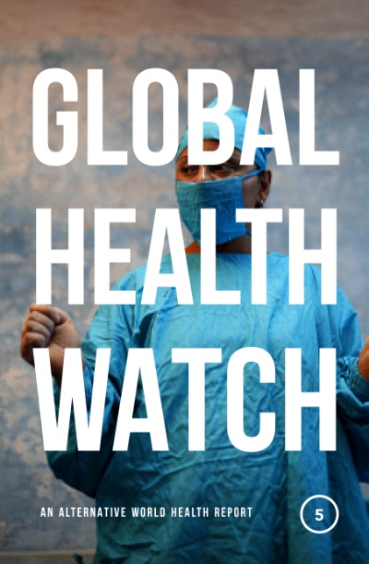

GHW5 is the latest edition of what remains the leading source for radical analysis in global and development healthcare.

For over a decade, Global Health Watch has been the definitive source for alternative analysis on health and healthcare, challenging conventional wisdom and pioneering innovative new approaches to the field. This new edition addresses the key challenges facing governments and health practitioners today, within the context of the UN’s Sustainable Development Goals.

Collaboratively written by academics and activists drawn from a variety of movements, research institutions, and civil society groups, its case studies cover some of the most pressing issues in world health, from the resurgence of epidemic diseases such as Ebola to antimicrobial resistance, climate change, and the ‘war on drugs’. Combining

rigorous analysis with practical policy suggestions, Global Health Watch 5 offers an accessible and compelling case for a radical new approach to healthcare across the world.

**CONTENTS**

**Section A: The global political and economic architecture**

A1: SDGs in the age of Neoliberalism

A2: ‘Leave No One Behind’ -- are SDGs the way forward?

A3: Advances and Setbacks in Latin America

A4: Structural roots of Migration

**Section B: Health Systems: Current issues and debates**

B1: UHC: Only About Financial Protection?

B2: Community Control in PHC

B3: Healthcare in the US: Understanding the Medical-Industrial Complex

B4 : Struggle of Health Workers in South Africa

B5: How PPPs undermine public services

B6: Access to Healthcare of Migrants in EU B7: Informalisation of Employment in Public Health Services in South Asia

**C: Beyond health care**

C1: Climate Change, Environmental Degradation and Health:

C2: Gendered approach to Reproductive and Sexual Health and Rights

C3: Health Reforms in Chile: Lack of Progress in Women's SRHRs

C4: Trade Agreements and Health of Workers

C5 : Public Health in the Extractive Sector

C6: The War on Drugs

**D: Watching**

D1: Money Talks at the WHO

D2: Private Philanthropic Foundations: What do they mean for Global Health?

D3: Management Consulting Firms in Global Health

D4: GAVI and Global Fund: Private Governance Structures

D5: Investment Treaties: Holding Governments to ransom

D6: Framing of Health as a Security Issue

D7: Politics of Data, Information & Knowledge

D8: Access and Benefit Sharing: The PIP Framework

D9: Total Sanitation programs at the cost of human dignity

**E: Resistance, Actions and Change**

E1: Social Movements Defend Progressive Health Reforms in El Salvador

E2: Contestations Concerning Management of Severe Acute Malnutrition

E3: People living with HIV in India: The Struggle for Access

E4: Community engagement in the Struggle for Health in Italy

**Global Health Watch 5**

**An Alternative World Health Report**

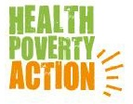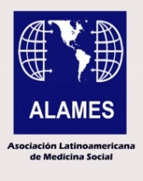

Find out more by visiting:

www.ghwatch.org, or e-mail

asengupta@phmovement.org

gargeya.t@phmovement.org